**Karan Arora**  **R.L. Institute M: 9416974837**

**Max Time : 1 ½ hr** **Class = 12th Biology Test**  **Max Marks : 35**

**BIOTECHNOLOGY**

1. Multiple choice questions : [ 1 X 10 = 10]
2. Stirred tank bioreactors have been designed for :

|  |  |
| --- | --- |
| a) Addition of preservatives to the product | b) purification of product |
| c) ensuring anaerobic condition in culture vessel | d) availability of oxygen throughout the process |

1. In RNAi, gene are silenced by using :

|  |  |  |  |
| --- | --- | --- | --- |
| a) ss DNA | b) ds DNA | c) ds RNA | d) ss RNA |

1. Given below is a sample of a portion of DNA strand giving the base sequence on the opposite strands. What is so special shown in it?

5’____GAATTC____3’

3’____CTTAAG____5’

|  |  |  |  |
| --- | --- | --- | --- |
| a) replication completed | b) deletion mutation | c) start codon at 5’ | d) palindromic sequence |

1. Which one of the following is commonly used in transfer of foreign DNA into crop plants?

|  |  |
| --- | --- |
| a) Meloidegyne incognita | b) Agrobacterium tumefaciens |
| c) Penicillium expansum | d) Tricoderma harzianum |

1. GEAC stands for :

|  |  |
| --- | --- |
| a) Genome Engineering Action Committee | b) Ground Environment Action Committee |
| c) Genetic Engineering Approval Committee | d) Genetic & Environment Approval Committee |

1. Which of the following is not a characteristic of the plasmid :

|  |  |  |  |
| --- | --- | --- | --- |
| a) Extra nuclear | b) single stranded | c) independent replication | d) circular DNA |

1. $α$- 1 antitrypsin is :

|  |  |
| --- | --- |
| a) an antacid | b) an enzyme |
| c) used to treat arthritis | d) used to treat emphysema |

1. An antibiotic resistant gene in a vector usually help in selection of :

|  |  |  |  |
| --- | --- | --- | --- |
| a) competent cell | b) transformed cell | c) recombinant cell | d) none of the above |

1. In genetic engineering, the antibiotics are used

|  |  |
| --- | --- |
| a) as selectable marker | b) to keep the cultures free of infection |
| c) to select healthy vectors | d) as sequence from where replication starts |

1. Bio piracy is :

|  |  |
| --- | --- |
| a) use of bio patents | b) thefts of plants and animals |
| c) stealing of bio resources | d) exploitation of bio resources without paying authorization |

1. Name the host cells in which micro-injection technique is used to introduce an alien DNA. [ 1 ]
2. Name the first transgenic cow. Which gene was introduced in this cow? [ 1 ]
3. Why and how bacteria can be made competent? [ 1 ]
4. Name the component used for staining the isolated DNA in the gel electrophoresis. [ 1 ]
5. What is gene gun? [ 1 ]
6. Why are molecular scissor so called? Write their use in biotechnology. [ 2 ]
7. Why do lepidopterans die when they feed on Bt cotton plant? Explain how does it happens. [ 2 ]
8. Why the ‘insertional inactivation’ method to detect recombinant DNA is preferred to ‘antibiotic resistance’ procedure? [ 2 ]
9. Suggest and describe a technique to obtain multiple copies of a gene of interest in vitro. [ 3 ]
10. Explain the different uses of biotechnology in medical field. [ 3 ]
11. Refer to the diagram of maturation of proinsulin into insulin to answer the following questions. [ 4 ]

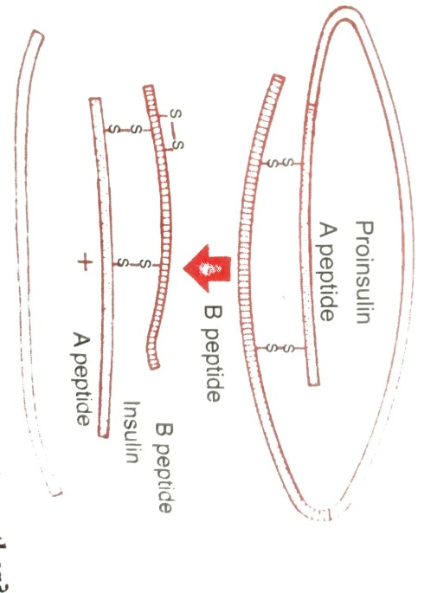

(i) How are two short polypeptide chain of insulin linked together?

(ii) State the role of C-peptide in human insulin.

(iii) Mention the chemical change that proinsulin undergoes, to be able to act as mature insulin

1. Rajesh was doing gel electrophoresis to purify DNA fragments. Given below is the sketch of the observation of the experiment performed by him. [ 4 ]

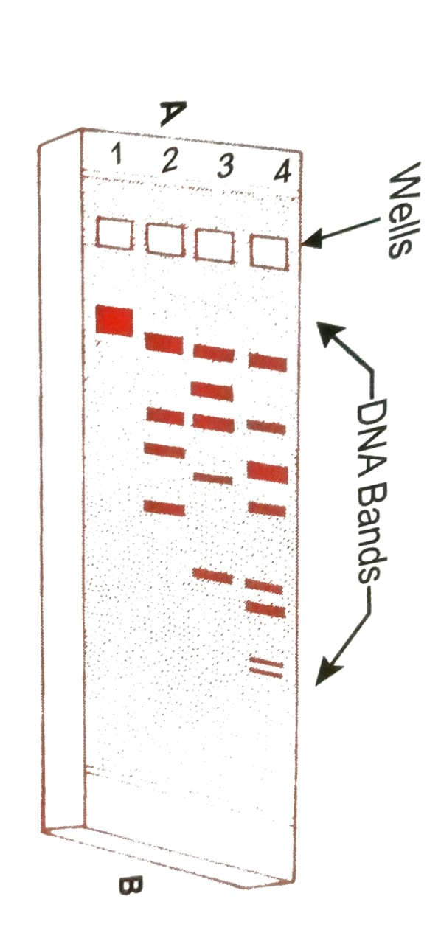

(i) At which end of he would have loaded the samples and where?

(ii) Analyse the reason for different position taken up by the DNA bands.

(iii) Elaborate the step he would have followed to visualized DNA bands.